**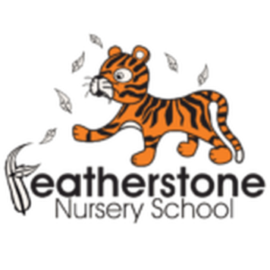 Featherstone News**

**June 2025**

Nursery News:

Chicks! Explorers have had an amazing time observing the hen’s eggs in the incubator. We were really pleased to have six healthy chicks!

We have learnt about how to care for them and we have even held them!

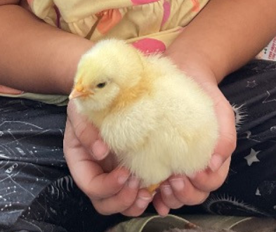

They will be leaving us to live a happy and healthy life on the farm.

Little Learners will be looking after Caterpillars after half – they have enjoyed reading The Very Hungry Caterpillar this half term so they are very excited about having their own caterpillars in the classroom.

Dates for your diary:

Thursdays at Osborne Nursery School – Stay and Play for under 2s. 9:45 – 11:15am

Monday 26th – Friday 30th May – HALF TERM

Monday 2nd June – NURSERY OPEN

Wednesday 11th June – Explorers to visit Beacon Park in Lichfield - see letters and Tapestry.

Thursday 3rd July – Little Learners trip to Sutton Coldfield park.

WC: 14th July – Leavers Celebrations! Details to follow.

Friday 18th July 2024 – LAST day of summer term.

WC: 1st September 2025 – nursery reopens for staff, followed by children. Please check with Key Workers for a start date.

z\\

Maths Workshops:

The maths workshops were a real success- thank you to all the parents and carers that came! We hope you had an insight into what we do at nursery. Let us know if you try out any of the advice we gave. There are posts on Tapestry with key number songs and ideas.

Startwell:

We have now been successful in achieving out Startwell award!! Thank you for your support to promote the messages and well done to the staff and children too. We will continue to promote the Startwell messages and teach the children about healthy lifestyles.

 Attendance is very important at Nursery. We like to see you for all of your sessions each week. We like families to aim for attendance to be between 95 and 100%. Look out for the Cool Kittens stickers

Congratulations to HEDGEHOGS and LADYBIRDS PM for the best attendance in Nursery in May 2024. FANTASTIC!! Well done to the parents and carers too. Aim for 95% or above!!



**Rights Respecting Schools Award (RRSA)**

June 20th 2025. World Refugee Day is held on June 20th. This is an annual event, held on the same date each year. World Refugee Day honours the strength and courage of refugees and encourages public awareness and support of the refugees, people who have had to flee their home lands because of conflict or natural disaster.

We are working towards reaccrediting the Silver Level of the Rights Respecting Schools Award (RRSA) and as part of this award we work with the children as well as with you to raise awareness about the UN Convention on the Rights of the Child.



Internet safety: We need to keep our children safe and help them to understand how to play games, use the internet and different devises safely.

A simple and effective way to get involved with your children and their lives online is through discussion. By maintaining an open dialogue with your child and encouraging them to talk to you about their internet use parents can help children access the amazing resources the internet has to offer whilst keeping them safe online.

C:\Program Files (x86)\Microsoft Office\MEDIA\OFFICE14\AutoShap\BD18234_.wmfC:\Program Files (x86)\Microsoft Office\MEDIA\OFFICE14\AutoShap\BD18234_.wmfC:\Program Files (x86)\Microsoft Office\MEDIA\OFFICE14\AutoShap\BD18234_.wmfC:\Program Files (x86)\Microsoft Office\MEDIA\OFFICE14\AutoShap\BD18234_.wmf

It is great to see the children bringing back their library books every Wednesday – we hope you are enjoying reading at home.

Recommended reading this month:

Shark in the Park by Nick Sharratt.

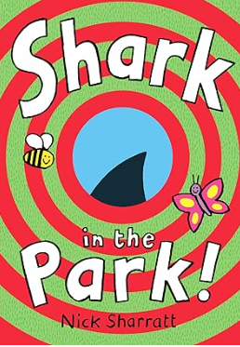

Timothy Pope has a brand new telescope and he's testing it out in the park. Peep through the die-cut holes in this book to see if you can spy a shark. Is that really a shark?

Perhaps you could make your telescope and see what you can see in the park!

**Transition:**

It will soon be time for some of our children to move up to their new schools or groups in nursery. We have planned lots of activities to support your child’s transition. Please see your key worker for further tips!

Here are some top tips for home:

* Talk about their new school – draw pictures or talk about what they will be doing
* Talk about how they are feeling. It’s good to express feelings.
* What changes have they experienced in the past? (New baby, new home?)
* Take a walk past their new school, talk about the route.
* Practice putting coats on and off and doing up zips/ press studs / buttons.
* Recognising their name
* Have fun with counting!
* Look at the new school website

We hope that you have all enjoyed half term and we look forward to seeing you all back at nursery from Monday 2nd June 2025.