** Featherstone News**

**May 2025** 

Nursery News:

The staff and children have been busy planting new plants as part of our gardening project. We were awarded another grant from Royal Horticultural Society. We were able to to buy new gardening tools, seeds, shrubs, and new planting tubs. We can’t wait to watch the plants grow and flower!

The Play House visited Nursery! We had a wonderful time with Juliette who helped us to act out the story of Handa’s surprise. Check Tapestry for more photos!

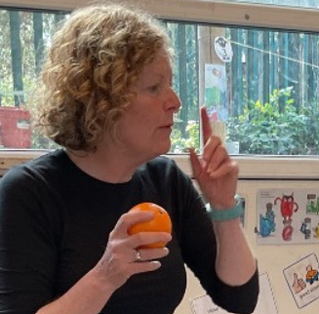 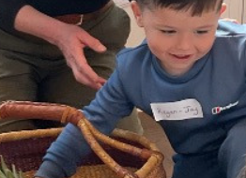

We would like to welcome all the new children to Featherstone Nursery! We love it here and we are sure you will too!

Dates for your diary:

Stay and Play 0 -2s 9:45am – 11am. THURSDAY at Osborne Nursery

Monday 5th May– May Bank Holiday NURSERY CLOSED

Wednesday 14th May – Academy photos Class groups

Wednesday 14th May – Quench Arts and Music sessions

Monday 19th May – Hatching experience arrives at Nursery – I wonder how many chicks we will have!

Monday 26th – Friday 30th May – HALF TERM

Monday 2nd June – NURSERY OPEN

Trips to local parks in June/July – watch out for dates and times.

SCHOOL FUND:

Featherstone Nursery collects school fund. We would recommend a donation of a pound a week or whatever you can afford. Thanks.

z\\

 Attendance is very important at Nursery. We like to see you for all of your sessions each week. We like families to aim for attendance to be between 95 and 100%. Look out for the Cool Kittens stickers

Congratulations to Badgers AM 95%and Ladybirds AM 96% for the VERY best attendance in Nursery in April 2025. FANTASTIC!! Well done to the parents and carers too. Aim for 96% or above!!

Transition to Primary School:

Thank you for letting us know which school your child will be attending in September 2025.

We are in the process of organising dates for the primary schools to visit the children at nursery and meetings between staff too.

We have been looking at different skills in order to get the children ready for school. This is linked to Ready, Steady Reception!

We have been learning to do up zips, buttons and take our socks on and off.

We will be sharing different skills to practice on Tapestry!



**Rights Respecting Schools Award (RRSA)**

Mental Health Awareness Week: May 2025

Anxiety is one is the most common mental health problems we can experience at any age. Mental Health awareness week will focus on anxiety and how we can prevent it becoming a problem. Mentalhealth.org.uk

We have achieved the Silver Level of the Rights Respecting Schools Award (RRSA) and as part of this award we work with the children as well as with you to raise awareness about the UN Convention on the Rights of the Child.



Internet safety:

Screen Time:  Screens are everywhere these days - from classrooms to bedrooms - and while they can offer educational benefits and entertainment, too much screen exposure may be interfering with one of the most essential needs for growing minds: sleep.

Thankfully, small changes can make a big difference. Here’s how to help your child reclaim their rest:

1. Introduce a “tech curfew”: Turn off devices at least an hour before bedtime to give the brain time to relax and promote melatonin production.

2. Make bedrooms screen-free zones: Keep electronics out of sleep spaces to strengthen the mental link between the bedroom and rest.

3. Go to bed and waking up at the same time daily—even on weekends—helps regulate internal rhythms.

4. Create a soothing wind-down routine: Encourage activities like reading, gentle stretches, or quiet music to cue the body for sleep.

5. Support overall sleep hygiene: Nutritious food, physical activity, and cutting back on sugar or caffeine.

Spring Curriculum:

Make sure that you have received your new half term curriculum plan from your Key Worker.This will tell you all about our topic

‘ Change’. You will also see this on our website.

The eggs will be arriving at Nursery in May and caterpillars for Little Learners.I wonder if we will have chicks or duckings?The children will be able to observe them hatching. They will learn all about how to care for the hatchlings and will watch them grow. We will post regular updates on Tapestry.

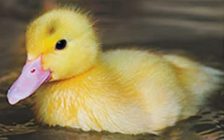

It is great to see the children bringing back their library books every Wednesday – we hope you are enjoying reading at home.

Recommended reading this month:

Titch by Pat Hutchins

Titch is little. Everything he has is little, from his little pinwheel to his little tricycle. His brother Pete and his sister Mary are big. Everything they have is bigger and better than what Titch has. Their kites fly high above the houses and trees, and their bicycles are large and fast. But when Titch plants a little seed, it begins to grow...and grow...and grow!

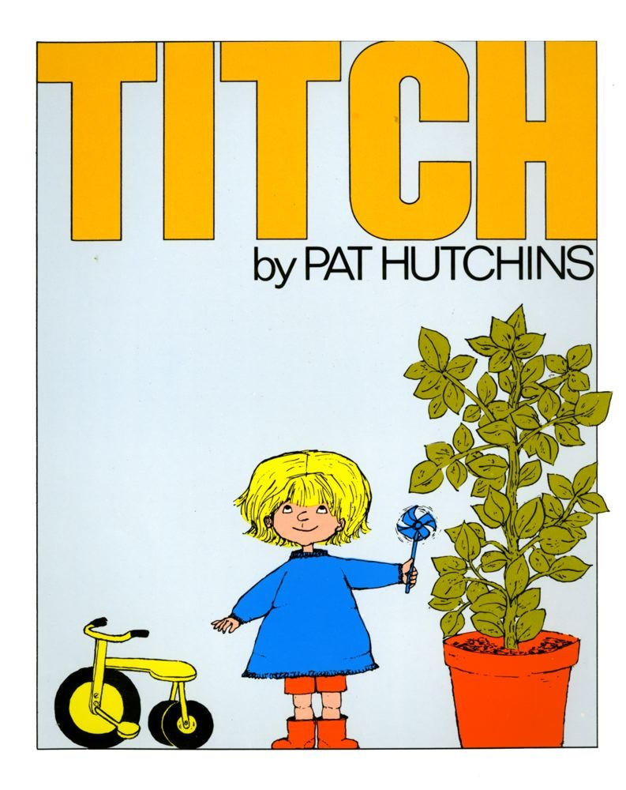

Temperatures are always changing! Please make sure that if it is sunny, apply sun cream to your child and provide a hat. If it does turn chilly or wet again, please make sure your child has a suitable coat and footwear.