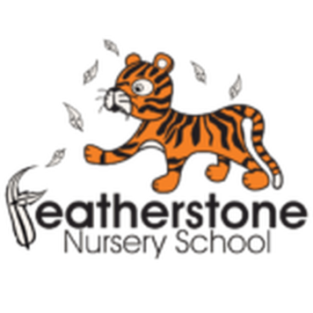 **Featherstone News**

**July 2025**

Dates for your diary:

Thursdays– Stay and Play 9:45am – 11am with Maddie at Osborne Nursery 0 -2 year olds

Transition events through July – Please ensure you check emails and letters for visits to your child’s new school.

July 2025 – Visits for new families at Nursery

WC: 7th July 2025 – Parent/ carer meetings – see Tapestry for details.

Thursday 10th July – Quench Arts visiting nursery to deliver music sessions

WC: 14th July – Leavers Celebrations! Details to follow, check Tapestry.

Friday 18th July 2024 – LAST day of summer term.

Monday 1st and Tuesday 2nd September 2025 – NURSERY CLOSED FOR STAFF TRAINING

SCHOOL FEES:

Please ensure that you have paid your child’s dinner money and your top –up funds by the end of the term.

What a wonderful year we have had! We would like to thank all parents and carers for their support over the year. As we come to the end of your child’s time with us at Featherstone Nursery School, we’d like to say a heartfelt thank you for all your support and involvement. It’s been a pleasure to watch your children grow and learn, and we’re so proud of everything they’ve achieved.

We wish you and your child the very best of luck as they start their next adventure at primary school. We know they’ll continue to shine!

We look forward to welcoming children back to nursery and new families too.

Children returning to Nursery School in September 2025

Children returning to Nursery School will come back in to school from **Wednesday 3rd**

**September.** You will have a letter confirming your child’s pattern of attendance. We look forward to seeing you in September. Please remember to supply nappies and changes of clothes in a named bag.

Thank you.

End of year reports: Our staff have working hard to write an end of report for every child. This will tell you about their successes and areas of development. They will be posted on Tapestry. Please read and comment.

Sun Safety: 

1.Wear sun cream and keep applying

2.Drink lots of water

3.Spend time out of the sunshine, especially between 11am and 3pm

4.Wear a hat

https://www.bbc.co.uk/cbeebies/watch/sun-safety-for-kids 



Attendance is very important at Nursery. We like to see you for all of your sessions each week. We like families to aim for attendance to be between 95 and 100%. Look out for the Cool Kittens stickers!

Congratulations to Caterpillars 89% AM and Robins 91% for the best attendance in Nursery in June . FANTASTIC!! Well done to the parents and carers too. Let’s aim for 95% and above in July.



We have achieved the Silver Level of the Rights Respecting Schools Award (RRSA) and as part of this award we work with the children as well as with you to raise awareness about the UN Convention on the Rights of the Child.

**Rights Respecting Schools Award (RRSA)**

July 7th 2025 is National Thank You Day!

A day to celebrate all the things that keep us connected in our communities, saying ‘thank you’ to each other – making a cup of tea, sharing a cake, lighting up the BBQ, and getting everyone together.

Who can you say thank you today?!

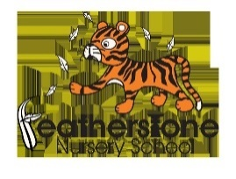

Internet Safety: Over the summer holidays please support your child when they use any devises like IPads or phones. Have a look at the advice below and keep your child safe. **Doing something is better than doing nothing – it is your responsibility**

* Speak to your internet provider if you are unsure. For detailed guidance on the different types of control, you can use this [online tool from Internet Matters](https://www.internetmatters.org/parental-controls/).
* Do not allow any devices in bedrooms – as parents go to sleep, children have a skill at re-awaking.
* Create rules around what’s OK and what’s not.
* Monitor websites and games before allowing children to surf and play freely.
* Ask them to take off headphones so you can listen in.
* Reduce screen time – encourage playing outdoors, sports and develop other interests.
* Talk to your child’s school, make sure academic work is up to date, look at their sleep habits.
* Always let your child know that they should always say if they see or hear anything online that makes them feel scared or uncomfortable and to never arrange to meet someone who they have met online.
* Let them know that they do not have to feel as though they have done something wrong, nobody is going to get cross and it is not their fault.

The nursery trip to Beacon Park was a huge success, a big thank you to all those that could come!

New friendships between parents were made, children said they had a great day and it was sunny. The children had such fun investigating the park, feeding the ducks, walking through Lichfield and catching the trains! A real adventure!

 

Little Learners will be visiting Sutton Park in July.

The children in Explorers have been reading stories about Supertato by Sue Hendre and Paul Linnett. Our younger children have been reading Shark in the Park by Nick Sharratt.

Have a look in the local library for more stories by these authors – they are good fun to read!

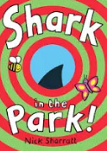

We hope you all have an enjoyable summer and remember to stay safe!