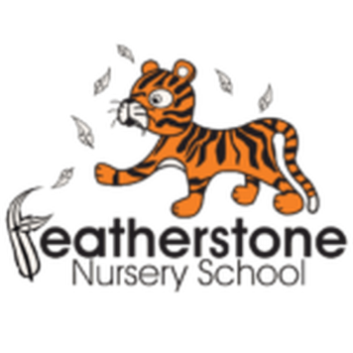 **Featherstone News**

**October 2024 **

Welcome to the Autumn term:

It’s great to see all of the children settling into nursery life, making new friends and getting to know their key workers. We will be posting videos and top tips on Tapestry to help your child at Nursery .

Look out for Startwell updates too.

Here are a few reminders for the start of term:

* Remember to keep an eye on Tapestry for updates and photographs
* ALWAYS send spare clothes for your child, named and in a bag
* We provide food and drink – we are a healhty school! You do not need to send in snacks.
* Keep in touch – talk to us and share any exciting news or ask us for advice.

Every Thursday at Osborne Nursery School - Stay and Play 0-2 year’s old– 9:45 – 11:15am

Wednesday 9th October – Animal Antics – Woodland animals will be visiting our setting!! Watch out for videos and photos

WB: 7th October – Playdough workshops for Little Learners

WB: 14th October – Environment walks for Explorers

WB: 21st October – Parent/ carer meetings to discuss your child with Key Workers. Look out for dates and times on Tapestry.

Monday 28th October – Friday 1st November 2022 – NURSERY CLOSED HALF TERM.

WB: 11th November: Nursery Rhyme Week – We’ll be learning lots of nursery rhymes during this week, which are great for developing children’s language skills.

Friday 20th December – END OF TERM

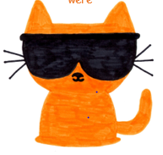

Attendance is very important at Nursery. We like to see you for all of your sessions each week. We like families to aim for attendance to be between 95 and 100%. Look out for the Cool Kittens stickers

Congratulations to BADGERS AM and Bumblebees AM for the best attendance in Nursery in September. 93%. FANTASTIC!! Well done to the parents and carers too.

Personal details

Please check that details we have for you are correct. Let us know straight away if you have moved house or changed your phone number.

Let Rachel or Rebecca know at our office.

Communication:

**Remember to telephone us on 0121 675 3408 if your child is too ill to be at nursery.** 

Please be on time when dropping off and picking up your children.



We have achieved the Silver Level of the Rights Respecting Schools Award (RRSA) and as part of this award we work with the children as well as with you to raise awareness about the UN Convention on the Rights of the Child.

**Rights Respecting Schools Award (RRSA)**

Article 13 (freedom of expression) Every child must be free to express their thoughts and opinions and to access all kinds of information, as long as it is within the law.

At Nursery we encourage all children to talk and share their opinions. We give children choices and teach them ways to communicate with adults and their friends.

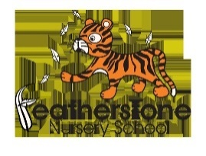

Internet safety:

Each month we will be looking at using electronic devises safely at home and sharing helpful tips. We need to keep our children safe and help them to understand how to play games, use the internet and different devises safely.



Forest School.

Forest School will be starting soon. Your team of trained practitioners have been busy preparing and planning the forest school sessions! Lindsey, Debra and Mariyah!

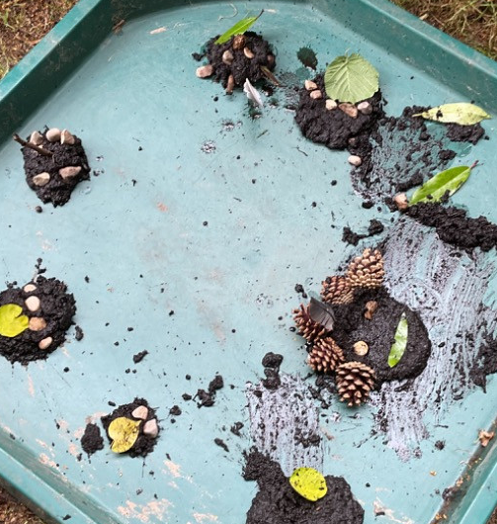 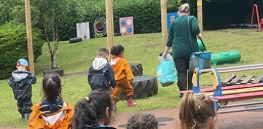

We visit the forest in all weathers so please send changes of clothes and send wellies!!

We will post dates and times on Tapestry.

We love to read!

Watch out for reading bags. We will be helping your child to choose a book each week to read at home with you.

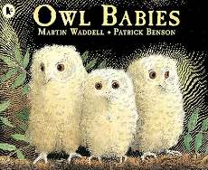

We will posting stories onto Tapestry for your child to watch. Our key text in Explorers is Owl Babies . Watch out for ‘Dear Zoo’ and ‘So Much’ coming soon.

Happy Diwali to all of our families that are celebrating! 