
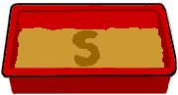

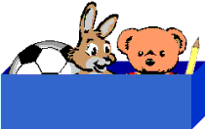
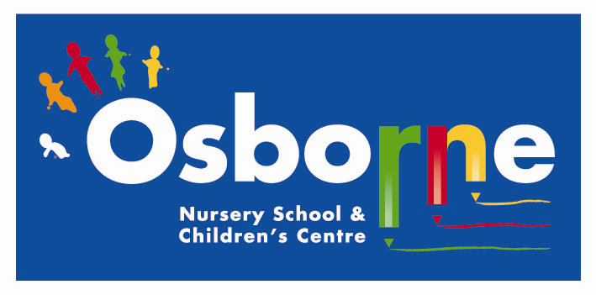

Learning through Play

Letters and Sounds

Other activities

Magnetic letters
Buy magnetic letters for your fridge, or for use with a tin tray. Find out which letters have been taught – have fun finding these with your child and place them on the magnetic surface.
Making little words together

Make little words together, for example, it, up, am, and, top, dig, run, met, pick. As you select the letters, say them aloud: ‘a-m – am’, ‘m-e-t – met’.
Breaking words up
Now do it the other way around: read the word, break the word up and move the letters away, saying: ‘met – m-e-t’.
Both these activities help children to see that reading and spelling are reversible processes.
Little whiteboards and pens, and magic boards, are a good way for children to try out spellings and practise their handwriting.
Your child might be trying to use letters from their name to write; this shows that they know that writing needs real alphabet letters.
Make or buy an alphabet poster.

'What does it start with?' Box
You will need:
- A box
- Several items each beginning with a different sound
- Corresponding letter cards

This game is similar to the common objects game on the previous page, but the emphasis now is on recognising the sounds the letters make. Ask your child to choose an object from the box, to think what its first sound is (remember it is the sound you are looking for rather than the alphabet name) and then to match the object with the relevant card.

Sand Tray or Finger Paints
Children enjoy writing letters with their fingers in a tray of sand or with finger paints. These ways provide good opportunities to teach correct letter formation.

Recognising Print carries meaning

This activity is quite useful when sharing a book with your child. Quite often parents say "He's not reading the book. He's remembering the story off by heart". They are recognising that the print has meaning. You can model this when pointing to the words as you read them and pick out letters etc.

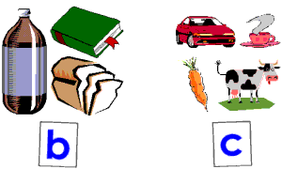
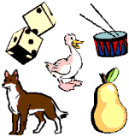
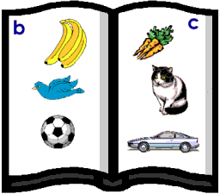
Which starts with a different
sound to the others?

Sounds Scrapbook
Write a letter at the top of each page of a scrapbook. Concentrating on a few letters at a time and collect pictures of objects that begin with those letters. Do not use as examples words where the first sound does not make its normal sound such as in giraffe, ship, cheese, and thumb. Stick the pictures on the appropriate pages.

Games For Recognising Letter Shapes…

Fishing for Sounds
You will need a few cards with individual letters. Attach a paper clip to each card. Using a small stick with a string and magnet, your child can fish for letter sounds. If your child can say the sound of the letter he/she wins the card, otherwise you win it.

Sequencing the Letters in your Child's Name
Providing the individual letter cards for each letter of your child's first name can be a useful way to teach the sequence of letters. Remember you will need to write a capital for the first letter and lower case for the rest.

If you want to print out the cards using a word processor use a font such as Century Gothic on PC which has not a. Show your child how to make the name first, before shuffling the cards for him/her to have a try. For a very long name work with the first few and build up a letter at a time.

Sound Games to Play at Home…

Common Objects
Collect several objects that begin with the same sound and make a card with this letter sound on it. Make a second group of objects beginning with a different sound and a card to go with those.

Discuss the sounds of the letters on the two cards with your child and shuffle the objects. Separate the cards on the floor and ask your child to put each object near the sound that it starts with. This activity can help your child to "hear" the first sound of a word.

Odd-one Out
Say a number of words, all but one of which -begins with the same sound. See if your child can pick out the odd one. It can be helpful to have the corresponding objects there for the child to look at.

I-Spy
For small children the usual way of playing that starts 'I spy with my little eye something that begins with ....' can be too difficult. You can make this easier by providing a clue. 'I spy with my little eye something that barks and begins with d'.

Why begin Teaching Reading through Games?

It is vital that early reading experiences are happy and positive. The aim should be not just for children to learn to read, but to enjoy reading. Whilst games may appear to be an indirect approach, they do protect a child from a feeling of failure. By 'playing together' both parent and child are relaxed. Where a child could feel pressured in a formal teaching situation he/she will usually enjoy reading activities in a 'play' situation. This leaflet aims to give you simple ideas to try.

The Sounds of Letters

Tips for teaching your child the sounds:

- It is important for a child to learn lower case or small letters rather than capital letters at first. Most early books and games use lower case letters and your child will learn these first at school. Obviously you should use a capital letter when required, such as at the beginning of the child's name, eg. Paul.

- When you talk about letters to your child, remember to use the letter sounds rather than the alphabet names of the letters: ay bee see dee ee . The reason for this is that sounding out words is practically impossible if you use the alphabet names. eg. cat, would sound like: see ay tee

- When saying the sounds of b, d, g, j and w you will notice the 'uh' sound which follows each, for example buh, duh... You cannot say the sound without it, however, try to emphasise the main letter sound.

